Title: Introduction to Composition Analysis on Landscapes by Ma Yuan
Originally published in Mandarin in The Bulletin of National Museum of History. Feb 2011. Taipei, Taiwan.
Author: KUANG, Lin
Abstract
Ma Yuan’s ability to portray extraordinary dimensions in landscape paintings rests in his unique judgment, understanding, and intuitive grasp of the natural world. This paper analyzes Ma Yuan’s landscape compositions using the Golden-Angled Triangle (GAT) principle, which is a golden ratio method distinct from that which is typically used to analyze Western artwork. In Ma Yuan’s landscape paintings, the relative positions of all major objects in the scenery are determined by GATs. These indispensable objects cannot be reduced in quantity, and nor can they be increased without throwing the entire work into disarray. The GAT principle not only gives Ma Yuan’s landscape compositions their basic uniqueness, it also demonstrates that Ma Yuan’s “one-side/corner” (Ma Bianjiao, or Ma Corner) style is similar in appearance to, but different in substance from, the bianjiao composition of Southern Song artists such as Li Tang and Xia Gui. Through the analyses of publicly acknowledged works by Ma Yuan, this paper will discuss his innovative artistic underpinnings, and propose that the GAT principle is a critical criterion for attributing landscape paintings to Ma Yuan.
Key Words: Ma Yuan; Golden Ratio; Golden-Angled Triangle; Chinese landscape paintings; Composition; Large Axe-Cut ; Da Fu Pi; Fan Kuan (Fan K'uan); Li Tang (Li T'ang); Xia Gui; Dai Jin; Compositional Formats; high distance, deep distance, and level distance to construct a full-scene "true landscape".
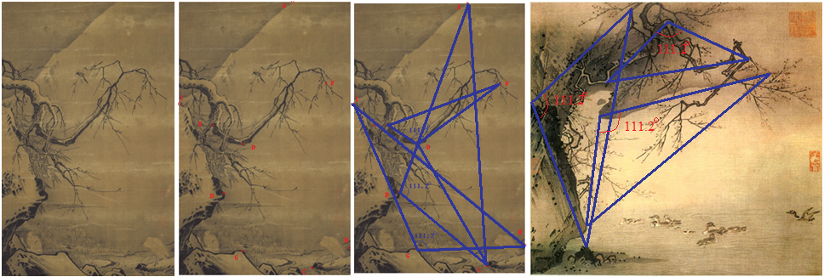
Fig 1 (Above Left Three) Ma Yuan, Two Egrets on a Snow Bank. Contains four GATs.
Fig 2 (Above Right) Ma Yuan, Swimming Ducks and Plum Trees and Stones. Exists four GATs.
Ma Yuan (Southern Song or Sung dynasty). Active from before 1189 to after 1223, a court painter. He is considered one of the top four great painters of the Southern Song period, alongside Li Tang, Liu Songnian, and Xia Gui. His style was said to follow that of Li Tang, and also inherits Fan Kuan’s principles. However, Ma received both praises and criticisms. The criticisms claim that his paintings are too simple and rough, referring to them as “destroyed mountains and depleted rivers” (can shan sheng shui). This metaphor alluded to the political troubles of the time, as two Song emperors were captured by the southward expanding Jin empire in 1127, forcing the Song capital to be relocated south of the Yangtze River (hence “Southern Song”). Ma Yuan’s supporters praised the beauty of his paintings, but have difficulty elaborating why they are beautiful. As evidence of his influence by Fan Kuan, Ma Yuan’s painting (i.e., The Dancing and Singing) followed the exact same composition of Fan Kuan’s only identified work, Travelers Amid Mountains and Streams (Palace Museum of Taipei). Both paintings are in compositional formats of “San Yuan” –three-distances format (high distance, deep distance, and level distance) to construct a full-scene true landscape.The only differences are that Ma’s painting contain less objects than that of Fan, and Ma used the “large axe-cut” (da fu pi chun) for solid objects, namely mountains and rocks. Fan, on the other hand, had big masses of objects fully fill the whole painting, and applied “rain-drop” strokes (yu dian chun or “nail top chun”) .
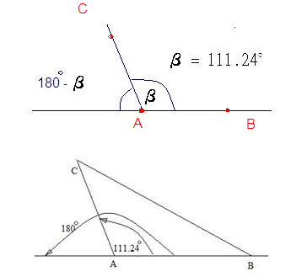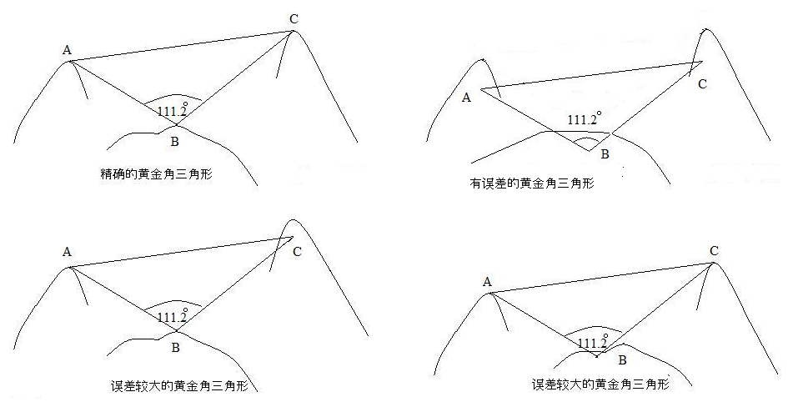
Fig 3 GAT illustrations.
However, the composition of the two paintings are the same, and both were controlled by several GATs, which made the related objects look harmonious and increased the 3-dimensional appearance from the top to bottom and from the left to right. It was this unexplained skill to enhance the traditional “three distances” (yuan) concept in Chinese landscape paintings, i.e., high, far, and deep distances (gao yuan, ping yuan, and shen yuan), that can now be explained by GATs. In about three hundred years later, Leonardo da Vinci did the same techniques for all of his masterpiece paintings. That technique combined with perspective approaches made da Vinci’s painting hid more secrets for people in the past five hundred years. This article introduced the Golden- Angled Triangle (GAT) theory and described examples of analyzing all of Ma Yuan’s identified paintings collected in the Palace Museums of both Taipei and Beijing.
Golden-Angled Triangles (GATs)
Fig 3 displayed a diagram to illustrate how a GAT is defined. Think about there being three objects A, B, and C in a painting, the angle CAB equaling 111.24º. The ratio of ∠CAB and the angle of the straight line BA (180º, or the sum of inner angles of a triangle), is 0.618 (111.24/180=0.618), producing a golden ratio! The lines AC and AB are extendable, the triangle ABC is rotatable using point A as the center of rotation. Unlike a rectangle, pyramid or other shapes of golden ratios, the GAT is not dependent on the area it can cover, (which is always an approximation), but on whether its three points land on objects of significance in an artwork. Hence, the GAT is more accurate and more dynamic.
A Golden-Angled Triangle is defined as below:
A Golden-Angled Triangle is defined by three essential factors or three key elements:
1 It contains a Golden Angle.
2 The three apex all must be the Golden Structure Points.
3 Two or more GATs may share a Golden Angle and at most two Golden Structure Points.
A Golden Angle is defined by three key elements:
1 Its value is 111.24º.
2 Apex is a Golden Structure Point.
3 Each of the two segments from the Golden Structure Point must end at another Golden Structure Point.
A Golden Structure Point is defined by three key elements:
1 It must be an important vision point in the painting.
2 It can form a Golden Angle with other two Golden Structure Points.
3 It is a perfect Golden Structure Point if it can form an accurate Golden Angle with other such points.
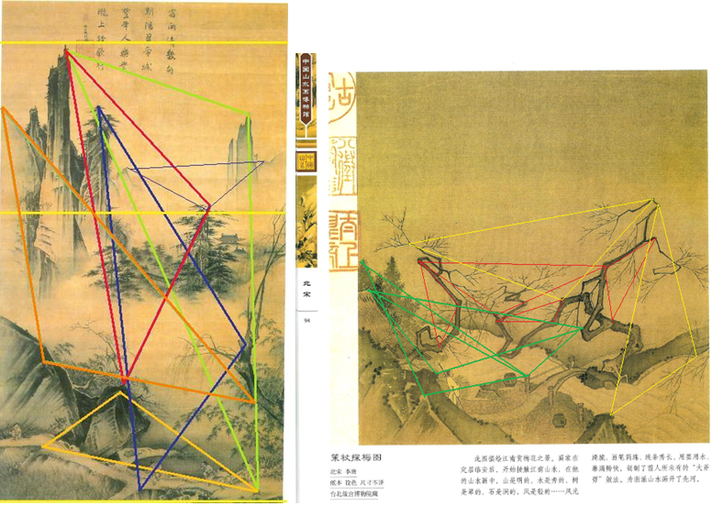 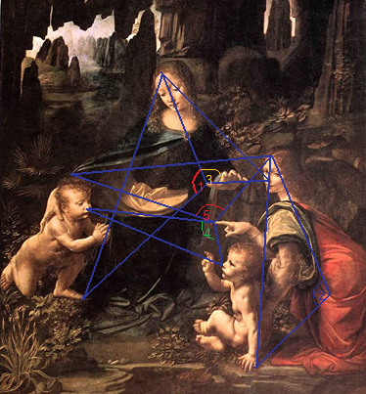
Fig. 4 Peasants Singing and Dancing
In Fig 3, let
β/180 = (180 – β)/β = φ
Get
β² + 180β – 180² = 0
Therefore
β = 180 x (-1 + √5)/2 = 180 x 0.618 = 111.24º
φ = 0.618
Analysis on Ma Yuan’s Landscape Paintings
In Fig. 4, there are six GATs forming the “Three-Distance” (San Yuan) composition. (To be continued)
Analysis on the Landscape Paintings of Ma Yuan’s Followers
Ma Yuan had influenced the Chinese landscape painting for several hundred years. Many excellent painters had tried to learn his style. Their works look similar enough to Ma Yuan’s in shapes, but could lag very far behind in expressions and attractiveness. This is explainable by their works’ lack of GATs. The three paintings a., c., and d. in Fig 5 used to be attributed to Ma Yuan in the Qianlong Emperor’s collection. There is no such accurate GAT found in those paintings. The painting b. was attributed to Dai Jin, but it could belong to Ma Yuan, as at least three GATs exist.
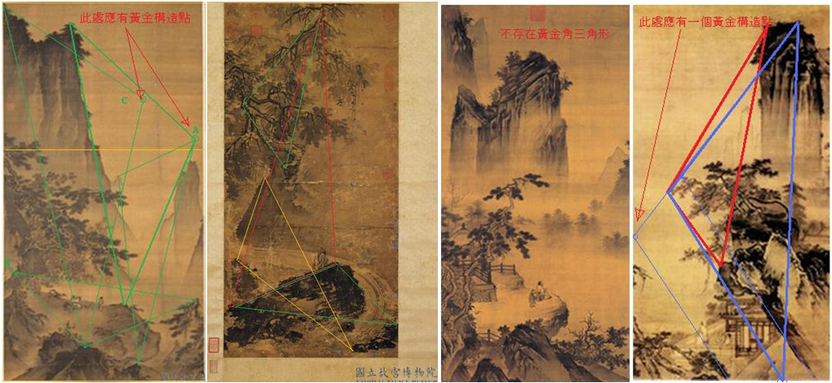
Fig 5 a. Recently attributed to Dai Jin b. Was attributed to Dai Jin c. Recently attributed to Zhong Li d. Recently attributed to Wang E
Analysis on All Existing Leonardo da Vinci’s Painting
The Annunciation kept at the Uffizi Gallery in Florence is usually considered Leonardo’s first complete work after leaving his master Verrocchio’s shop. This painting has been commonly noted for a number of composition flaws, which are often attributed to Leonardo’s relative youth at the time. We argue that some of these flaws can be explained by Leonardo’s attempt to apply Golden Ratio principles. Thus, it was not amateurish composition per se, but rather an immature experiment at unifying art and science, that has led to some of the seemingly obvious deficiencies in Annunciation.
In Annunciation, we found four GATs (blue, numbered 1-4), along with other shapes that meaningfully apply the Golden Ratio (Fig. 2). GAT 1 is formed by having its vertices land on the center top of the Virgin Mary’s forehead, her left elbow, and the bottom leftmost (viewer’s perspective) part of her dress. GAT 4 has a similar effect on the Archangel Gabriel, while GATs 2 and 3 establish the relative positions between the Mary, Gabriel, and the Bible stand, which is the most visible piece of furniture. Pietro C. Marani critiqued Annunciation as “not entirely successful in its handling of perspective and anatomy,” noting that Mary “is seated too far back for her right arm to reach the left side of the book on her [Bible] reading stand.” Yet Leonardo, believing in the power of the Golden Ratio, used GAT I to connect Mary, Gabriel, and the Bible stand. This then allowed the Bible stand, an important symbol of Christian faith, to be placed right at the Golden Ratio width (1 width: 0.68 width) of Annunciation (see Fig 2. yellow vertical line). Thus, Leonardo’s misjudgment of “perspective and anatomy” may have been the price he paid for his ambitious experiment to harmonize the most visually and symbolically important points of Annunciation by applying Golden Ratios.
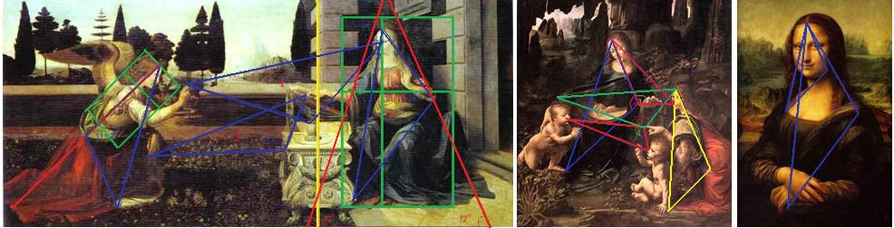
Fig 6 Leonardo da Vinci ‘s paintings. a Annunciation b. The Virgin of the Rocks (Louvre, Paris) c. Mona Lisa
Considering that Leonardo always applied principles of linear perspective, The GAT as we have presented it in this article is best understood as a projection of a three-dimensional triangle that exists in a virtual three-dimensional space on a painting’s actual two-dimensional plane of surface. In the The Virgin of the Rocks (Louvre, Paris), for instance, GAT 4 is comprised of two focal points that are located on three different levels of “depth”. As a result of this GAT lying in visual 3-D space, it would have an angle that is less than 111.2⁰, but if projected on a visual 2-D surface, it would still be 111.2⁰. The London version, usually considered an inferior copy created after Leonardo refused to hand in the first one, show lesser accuracy in the application of GAT 3, and one less GAT due to missing pointing finger near the center.

